**Analyzing Toxicity and Cancel Culture in Social Media Using Topic Modeling**

5. <https://animexnews.com/mrbeasts-involved-in-serious-allegations/>

6. <https://old.reddit.com/r/CancelCulture/comments/1ct60ez/my_cancel_story/>

7. <https://old.reddit.com/r/CancelCulture/comments/1b7g03d/trader_joes_lost_at_sea_cancelled_and_banned/>

8. <https://www.vice.com/en/article/cancel-culture-meaning/> ***

**Medium:**

9. <https://medium.com/@saffron.thewriter/percy-hynes-white-and-the-danger-of-cancel-culture-part-1-explainer-1a29270fd47d> ***

10. <https://medium.com/@reverieofthedead/cancel-culture-as-a-byproduct-of-misused-words-and-manufactured-wrongs-647198f6e86c> ***

11. <https://medium.com/@mawovan/against-sectarianism-slander-and-cancel-culture-in-the-palestine-solidarity-movement-8b2cf4b21e46> ***

12. <https://medium.com/@adhvik19m/cancel-culture-0ca154e3aafa> ***

13. <https://medium.com/trill-mag/the-inevitability-of-cancel-culture-f2b81aef3007> ***

14. <https://medium.com/@sandra.pragana/the-cancel-culture-debate-accountability-or-censorship-f2e2b0ab72c3> ***

15. <https://medium.com/@brandencollinsworth/why-we-need-to-cancel-cancel-culture-c38011d1c7ec> *** positive vibe cancel culture

16. <https://medium.com/@californiayouthstemproject/cancel-culture-the-psychology-behind-the-storm-2c3b1f974245>

17. <https://medium.com/@zitalucacsatho/the-dark-side-of-cancel-culture-a-modern-witch-hunt-1a01e908b7ad>

18. <https://medium.com/illumination/how-cancel-culture-can-change-society-for-the-better-a06df3bdc398> positive vibe cancel culture

**Important website:**

19. <https://www.pewresearch.org/internet/2021/05/19/americans-and-cancel-culture-where-some-see-calls-for-accountability-others-see-censorship-punishment/>

20. <https://www.ucf.edu/pegasus/is-cancel-culture-effective/>

21. <https://www.depts.ttu.edu/rise/Blog/cancelculture.php>

22. <https://therapygroupdc.com/therapist-dc-blog/the-psychology-of-cancel-culture-impacts-on-mental-health/>

23. <https://www.aei.org/articles/the-dangerous-evolution-of-cancel-culture/>

24. <https://edition.cnn.com/2023/05/12/asia/cancel-culture-law-singapore-intl-hnk>

25. <https://www.enzuzo.com/blog/cancel-culture-examples>

26. <https://gettysburgian.com/2023/11/canceled-or-popularized-the-rise-of-cancel-culture/>

27. <https://desktime.com/blog/cancel-culture-in-the-workplace>

28. <https://www.workthegreymatter.com/cancel-culture-how-it-works-four-useful-examples/>

29. <https://nycmuseumgallery.org/1196/entertainment/how-has-social-media-affected-cancel-culture/>

30. <https://www.essencemediacom.com/news/cancelculture>

31. <https://www.linkedin.com/pulse/sidestep-cancel-culture-3-ways-manage-your-reputation-lida-citro%C3%ABn/>

32. <https://www.npr.org/2021/02/10/965815679/is-cancel-culture-the-future-of-the-gop>

33. <https://www.forbes.com/councils/forbescoachescouncil/2020/03/25/one-way-forward-from-a-cancel-culture-to-an-accountable-culture/>

34. <https://time.com/5735403/cancel-culture-is-not-real/>

35. <https://www.dictionary.com/e/pop-culture/cancel-culture/>

36. <https://davidlat.substack.com/p/the-canceling-of-the-american-mind>

37. <https://capclaw.com/feedback-responses-to-cancel-culture-is-illegal-at-work/>

38. <https://www.peoplemanagement.co.uk/article/1848776/hr-achieve-balance-cancel-culture-free-speech>

39. <https://lens.monash.edu/@a-different-lens/2024/04/05/1386422/the-consequences-of-cancel-culture>

40. <https://reputationcrisis.org/blog/cancel-culture/>

41. <https://www.frontiersin.org/journals/political-science/articles/10.3389/fpos.2022.805008/full>

42. <https://journals.plos.org/plosone/article?id=10.1371/journal.pone.0228723>

43. <https://rsisinternational.org/journals/ijriss/articles/selected-students-perceptions-and-attitudes-on-cancel-culture-reflections-on-public-opinion-attribution-theory-compassionate-education-and-restorative-justice/>

44. <https://papers.ssrn.com/sol3/papers.cfm?abstract_id=4715439>

45. <https://www.cbsnews.com/news/cancel-culture-internet-joke-anything-but/>

46. <https://www.nytimes.com/2021/03/04/books/dr-seuss-books.html>

47. <https://www.forbes.com/sites/petersuciu/2021/02/16/is-gina-carano-a-victim-of-social-media-cancel-culture/?sh=7f96ad992e0e>

48. <https://www.thewrap.com/coming-back-from-cancel-culture-means-self-reflection-experts-say-the-twitter-mob-is-us/>

49. <https://www.thenation.com/article/society/republicans-cancel-culture-kaepernick/>

50. <https://www.forbes.com/sites/danabrownlee/2021/07/01/is-cancel-culture-really-just-long-overdue-accountability-for-the-privileged/?sh=78c0afde3a22>

51. <https://daily.jstor.org/cancel-culture-is-chaotic-good/>

52. <https://pmc.ncbi.nlm.nih.gov/articles/PMC11671789/>

53. <https://www.mdpi.com/2079-9292/10/11/1332>

54. <https://theseahawk.org/30325/thelatest/opinion-cancel-culture-is-toxic-and-does-more-harm-than-good/>

55. <https://www.newportacademy.com/resources/mental-health/teenage-cancel-culture/>

56. <https://www.insidehook.com/internet/youthsplaining-everything-you-need-to-know-about-cancel-culture>

57. <https://www.pewresearch.org/short-reads/2022/06/09/a-growing-share-of-americans-are-familiar-with-cancel-culture/>

58. <https://www.forbes.com/sites/kianbakhtiari/2020/09/29/why-brands-need-to-pay-attention-to-cancel-culture/>

59. <https://theconversation.com/can-we-confront-cancel-culture-by-finding-common-ground-between-moderate-leftists-and-wokists-254571>

60. <https://edition.cnn.com/2021/03/07/us/cancel-culture-accountability-reality-trnd/index.html>

61. <https://www.theatlantic.com/ideas/archive/2022/04/cancel-culture-debate-needs-greater-specificity/629654/>

62. <https://mentalhealthathome.org/2021/04/09/what-is-cancel-culture/>

63. <https://nypost.com/article/what-is-cancel-culture-breaking-down-the-toxic-online-trend/>

64. <https://axis.org/blog/an-introduction-to-cancel-culture/>

65. <https://inews.co.uk/culture/film/johnny-depp-proof-cancel-culture-doesnt-exist-3660509?srsltid=AfmBOoqarYxm_ZkFS9-Gs1026KLGct9NpQ5466Rp50FizwmTUFIBYMEm>

66. <https://www.forbes.com/sites/evangerstmann/2020/09/13/cancel-culture-is-only-getting-worse/>

67. <https://nz.news.yahoo.com/jade-thirlwall-scared-cancel-culture-140127873.html?guccounter=1&guce_referrer=aHR0cHM6Ly93d3cuZ29vZ2xlLmNvbS8&guce_referrer_sig=AQAAADlrwQM5_YB8ONQjKMx2v7im1AJcDTtLZPXrnVCHK67D37sHv6YlF9Av1ttKacyKGSUEv-4f6wM1p2GMaoMeVaF6knioQjlgY8rM-ze7v-EV849CaART_lKc6Db1ObuSy9fFMwbyzyNz3zpgo5S2djgfDTX_QuoG8wVasqhdkkIJ>"

20 number url date link: <https://cah.ucf.edu/news/newsroom/page/2/?dept=11&utm_source=chatgpt.com>

Preprocessing:

**1. Contractions** are shortened forms of words or word groups where letters are omitted and replaced by an apostrophe.  
For example:

* "don't" → "do not"
* "I'm" → "I am"
* "he's" → "he is"

**2. Lemmatize_words(tokens)**

* Lemmatization converts words to their **dictionary base form**:
  + "running" → "run"
  + "better" → "good"
  + "cars" → "car"
* Makes words **semantically accurate** for analysis.

**stem_words(tokens_lemmatized)**

* Stemming cuts words down to their **root**:
  + "run", "running", "runs" → "run"
  + "studies", "studying" → "studi"

DTM

#### What is a Corpus?

#### A **Corpus** is a structured collection of documents used in **text mining**.

#### In R, tm::Corpus() wraps your text into a format suitable for further processing (e.g., tokenizing, term matrix creation).

#### 

#### What is a DTM?

#### A **Document-Term Matrix** is a table where:

* **Rows** = documents
* **Columns** = words (terms)
* **Cells** = frequency of the word in that document

#### control = list(wordLengths = c(3, Inf))

* Filters out very short words (less than 3 characters).
* Keeps words of length 3 and more.

**Visualizations:**

**1. Word Cloud for Each Topic**

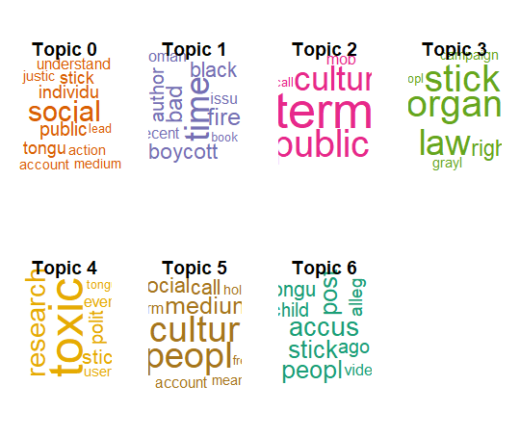

**2. Top 10 terms per topic**

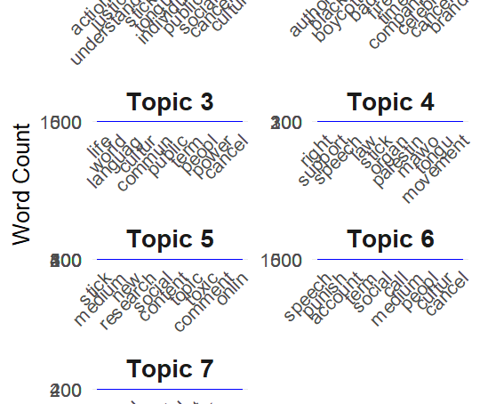

**Number of Documents by Dominant Topic and Number of Documents by Topic Weightage**

1. "This chart shows how many documents had each topic as their most dominant topic meaning the topic with the highest proportion (γ value) for that document. For example, Topic 1 ('Public Ethics & Cancel Culture Ideology') is the dominant theme in most articles, followed by Topic 6 and Topic 2. This tells us what most documents are mainly about."

**2.** "This chart sums the topic proportions across all documents, even if the topic is not dominant. It shows how frequently and strongly each topic appears in the whole dataset. While Topic 1 is still the most important, we see some topics like Topic 3 or Topic 7 contributing more than expected even if they aren’t dominant in many documents."

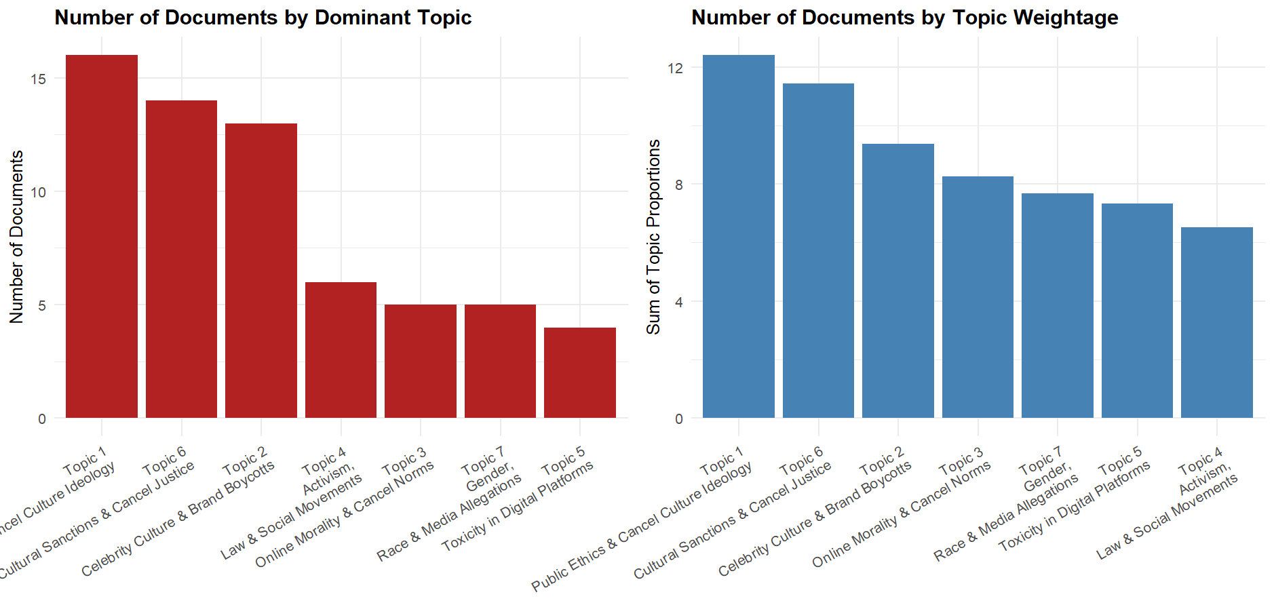

**Sankey diagram**

This Sankey diagram visualizes how all documents are distributed across different topics. Each flow represents the number of articles whose dominant theme matches a topic. It's a clear way to show proportional topic distribution in an intuitive, interactive format.

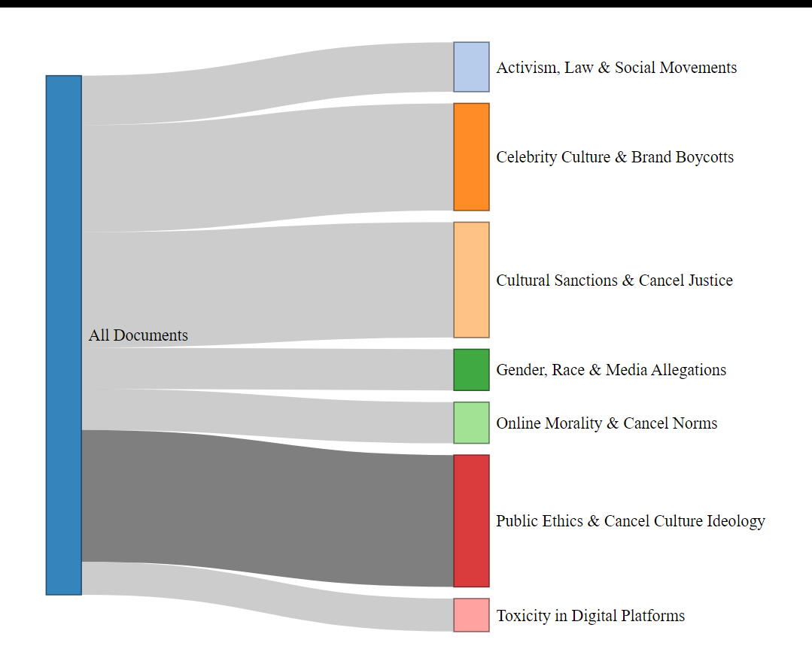

LDA visualization using LDAvis:

This LDAvis tool gives me an interactive way to explore the topic modeling results. It helps me understand how topics differ, what key terms define them, and how documents are distributed across topics. It combines both frequency and relevance of words, making interpretation more intuitive and transparent.

